 | The CAMECA IMS 7f and 4f-E7 Software user’s guide  Isotopes  00 45 610 694 - Type 108 – Indice A
0000.doc

Index

Contents

1. Processing the results with the isotope spreadsheet 2
1.1 Overview 2
1.2 The spreadsheet EM and Faraday corrections 4
1.3 The Main Spreadsheet panel 6
1.3.1 The spreadsheet correction boxes 7
1.3.2 Other fields of the spreadsheet panel top 7
1.3.3 The spreadsheet results 8
1.3.4 The File menu 8
1.3.5 The Ratios menu 9
1.3.6 The Options menu 10
1.3.7 The ratio defining box 10
2. The spreadsheet computed cells 12
2.1 Computation over one block data 14
2.2 Computation over the cumutaled data 15
3. Appendix: Fundamental of Statistics 17
3.1 Binomial law, poisson law, Normal law 17
3.2 Properties of the normal law 18
3.3 Consequence for the ion counting 20

Contents ↑

Processing the results with the isotope spreadsheet

Overview

The Isotope program is dedicated to the following purposes:

- To define the ratios which must be displayed and computed
- To display the isotope ratios as final results of the analysis
- To modify the correction parameters taken into account in the ratio computation, and to display therefore the different steps of the computing process which transforms the raw data into the final result.
- To estimate the uncertainty of the isotope ratio measurement and to help for searching for the causes of non-reproducibility.

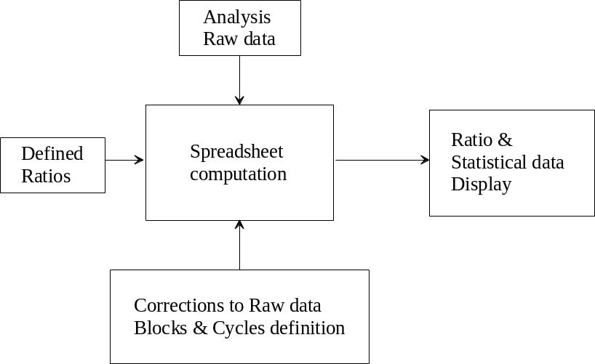

This last task requires to tackle with some statistical issues. An appendix presents some basic results of statistics. Some comments are necessary to explain how to apply these statistical results to the ion counting detection.

In the case of using an EM for measuring the ion signals, it is clear that a large enough number of counts is necessary to estimate a ratio at a given accuracy. It is explained in the appendix § Fundamental of Statistics, that, when measuring N counts during a given time T, the unavoidable dispersion on this measurement is N^{1/2}, provided that N is larger than a few units. (This is also true in the case of FC measurement, but this uncertainty is then always dominated by the preamplifier noise). Consequently, when a ratio is derived from two numbers of counts N₁ and N₂, there is an unavoidable uncertainty which can be expressed as
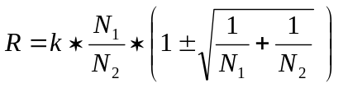
As it is explained in the appendix § Fundamental of Statistics, this formula is slightly more complicated in the general case when the ratios are defined as
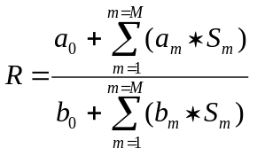
The spreadsheet allows to divide the overall analysis into sub-measurements and to compare the unavoidable uncertainty (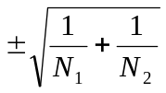), in the more simple case) , labelled in the spreadsheet as Poisson (%) to the actual experimental standard deviation of the mean, labelled in the spreadsheet as Std error mean (%), measured among the set of considered sub-measurement. A sub-measurement may be an elementary analysis cycle, or a block of cycles. When both Poisson and Std error mean are very close, it can be deduced that there is no other cause of dispersion than counting statistics within the analysis.
When this criterion is not met in the case of EM measurement or when FC measurements are involved in a ratio definition, the spreadsheet allows to investigate if the measured dispersion is of stochastic type or drift type. If the dispersion is stochastic, it will be possible to estimate the uncertainty of the overall measurement. This will be not possible in the case of a drift dispersion.
In the spreadsheet, the complete set of N=n*M cycles are divided into M blocks of n cycles.

Criterion for stochastic dispersion | (Std error mean)_{among blocks} =  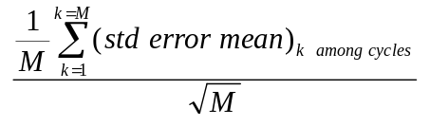
Uncertainty | 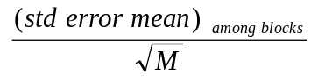

In the case of drift dispersion, though the dispersion value is of interest, a confidence interval cannot be deduced. It is necessary to run several analyses to check if the criterion for stochastic dispersion is met for this set of analysis. The couple (Blocks, cycles) is then replaced by the couple (Analysis, Blocks).

As it can be seen, the spreadsheet table is divided into two parts. The upper part displays the data computed over a single block, while the lower part displays the data computed over the overall analysis cycles. In the first case, the cycle is taken as elementary measurement and in the second case with the selection OVER BLOCK, the block is taken as elementary analysis.

The user may process the raw data by himself. It is possible to export data to ASCII files or ISO format. (See the functions File>Export to Excel and File>Save as in § The File menu)

WARNING: The Raw data are always expressed in counts per second.

As the counting time is always contained in the raw data files, it is always possible to compute the number of counts per cycle for every species.
Contents ↑

The spreadsheet EM and Faraday corrections

The EM deadtime
Let's assume that the EM counting system is such that after the leading edge of a counted pulse, the system is paralysed during a so-called deadtime τ. If N_{meas} pulses are actually counted during one second, that mean that the effective counting time was not 1 second but (1-Nτ). This leads to the deadtime formula:

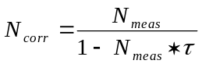

On the IMS 7f / 4fE7, the EM deadtime is normally determined by the hardware (See User's guide for Multicollector). However, note that the deadtime is not the single parasitic effect which depend on the count rate. Other phenomena are involved in the EM measurement process, such as the EM amplifier baseline drift which is caused by the fact that the EM amplifier is AC coupled. Finally, τ can be considered as well as an empirical first order correction with respect to the counting rate.

The EM yield and background.
Even at low count rate, a part of the secondary ions are not detected by the EM system. This yield Yield is normally determined by comparing both FC and EM signals for a count rate close to 10⁶ cps.
When no secondary ions are emitted, some parasitic counts are detected by the EM. This background signal Bkg can be measured. Generally, it is close to a few counts per minute. Finally, the full correction formula of EM detection can be expressed as
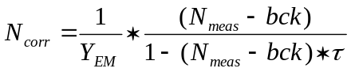

The linear drift correction
When ratios are calculated within a cycle, it is clear that the different masses are measured at different time and that primary current drift may occur or even if the primary current is stable enough, secondary signal drift may occur for various reasons. It can be therefore desirable to drift back the measurements so that all the cycle mass measurements could be considered as simultaneous. When the linear drift is ON, this drift back can be attempted by interpolating all the mass measurement at the location of the first mass in a time scale.
Note that such an interpolation is of very small interest regarding the overall result, since it can be demonstrated easily that the relative error ε resulting from a signal drift is
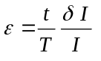

Where t is the delay between the 2 ratio mass measurements, within a cycle, T is the overall analysis time and δI/I, the relative signal drift between the beginning and the end of the analysis.

Faraday corrections
In the Faraday mode, the dominating error is the offset drift. The offset measurement must be performed before the analysis using an automatic routine (see the Tools software guide). Once recorded, the FC offset will be applied in the spreadsheet panel if the boxes Bkg is checked.

In the detection Setup panel, it is expected that the EM Yield is different from 1 and the EM deadtime different from 0. In the spreadsheet, both the EM Yield and EM deadtime corrections must be applied.

In the case of FC detection, the Bkg correction should be determined with the FC calibration routines.

Contents ↑

The Main Spreadsheet panel

The Spreadsheet panel can be displayed by loading any analysis file of .dp format in the File menu (File>Open fonction).

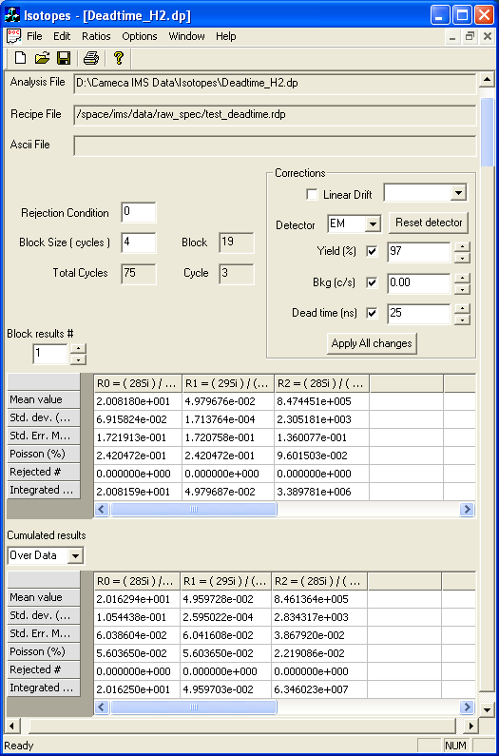

Contents ↑

The spreadsheet correction boxes

This box allows to define for each detection channel a set of correction parameters (Yield, Bkg, Deadtime). As the analysis species table contains the correspondences between measured mass M_{m}, and a detection channel, it is finally possible to build a Mass correction table [m, Yield_{m}, Bkg_{m}, Deadtime_{m}]. For the use of these parameters, see below the section § The spreadsheet computed cells. For some comments about these corrections, see below the Appendix § The EM and Faraday corrections.

For every loaded analysis raw data, these parameters can be further modified, without modifying the content of the setup file. The results are updated after a click on the button Apply all Changes. A click on the button Reset detectors allows to set back the parameter values present at the time of the analysis acquisition and which are saved together with the raw data in the .dp file.

The DISPLAY / EDITING FIELDS Yield, Bkg, Deadtime display by default the parameter values present at the time of the analysis acquisition. They can be further edited. A scrolling menu allows to select the corrections for the EM or the FC.

The Yield, Bkg, Deadtime checkboxes enable or disable the respective corresponding corrections according if they are checked or not, respectively. See the above section § The EM and Faraday corrections. The results are updated after a click on button Apply all Changes.

The Linear Drift checkbox enables or disables the linear drift correction. When the linear drift is on, a scrolling menu allows to select the species whose time scale is selected for the linear drift interpolation. See the above section § The linear drift correction. The results are updated after a click on button Apply all Changes.
Contents ↑

Other fields of the spreadsheet panel top

Analysis file (DISPLAY FIELD) The analysis acquisition filename and path corresponding to the current spreadsheet data (.dp extension).

Recipe file (DISPLAY FIELD) The analysis recipe filename and path corresponding to the current spreadsheet data (.rdp extension).

Rejection condition (DISPLAY / EDITING FIELD) It must be an integer. Let us call it n_{rej}. This field can be further edited. Whenever statistical computations over a set of data are required, a preliminary computation of the pair (average, σ) is achieved for each cycle. Then, all the data outside the interval [average - n_{rej}σ, average + n_{rej}σ] are rejected, and the final computation does not take into account the rejected data. If n_{rej} set to zero, no rejection is performed on the data.

Block size (EDITING FIELD) is the number of cycles per block. The number of blocks is then deduced from the analysis total number of cycles and displayed in the Block box (diplay field).

Cycle (DISPLAY FIELD) If the spreadsheet displays the current analysis (option File>Online, see below), the Cycle field displays the index of the current cycle within its block. If not, it displays the last cycle within its block.

Block (DISPLAY FIELD) Number of blocks, taking into account the total number of cycles displayed in the spreadsheet field Total cycles and the number of cycles per block edited in the spreadsheet field Block size. If the spreadsheet displays the current analysis (option File>Online, see below), the Block field displays the index of the current block.

Total Cycles (DISPLAY FIELD) Total number of cycles.
Contents ↑

The spreadsheet results

There are two main spreadsheet tables: the top one presents the results for a given block, while the bottom one presents the cumulated results computed in the Over Block or in the Over Data mode.

Block (SCROLLING BUTTONS) These buttons allow to change the Block # for which the results are displayed in the Block results top spreadsheet table. When the number is changed, the displayed results are updated accordingly.

Cumulated results (SCROLLING MENU) It allows to choose between Over Block or in the Over Data mode. When the selection is changed, the displayed results are updated accordingly.

The spreadsheet tables include six lines corresponding to the following quantities:
- Mean value
- Std. dev. (STDE)
- Std. Err. Mean (%)
- Poisson (%)
- Rejected #
- Integrated mean
The details of these calculations are given in § The spreadsheet computed cells.

Each column corresponds to a given ratio defined by the operator, the ratio formula being displayed on the top of the column. The formula is shown entirely by placing the mouse on the top of the column. The width of each column can be modified: this function becomes available when the mouse is placed on the border of a given column.
Contents ↑

The File menu

File>New allows to create a new empty spreadsheet.

File>Open allows to load in the spreadsheet previously saved data (.dp file). This function opens a file manager dialog box.

File>Close allows to close the present spreadsheet.

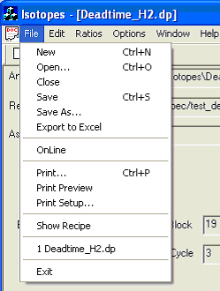File>Save / Save as allows to save in an Ascii file the spreadsheet statistical results together with the main information, such as the parameters used for the data correction. The format of the Ascii file is identical to the one for the printing using the File>Print function.

File>Export to Excel allows to save in an Ascii file the spreadsheet statistical results together with the main information, such as the parameters used for the data correction. The format of this Ascii file is different from the one obtained using the File>Save as function. This format has been optimised for an easier loading in the Excel® program.

File>Online allows to launch the online mode, the spreadsheet computation is applied to the current acquisition analysis (if the current acquisition is of a depth profile type). The spreadsheet results are updated at the end of each cycle.

File>Print allows to print the spreadsheet statistical results together with the main information, such as the parameters used for the data correction.

File>Show recipe displays the acquisition conditions for the currently loaded file in a dedicated box (Ascii format).

The filenames for the last four loaded depth profile files are displayed on the bottom of the File menu.
Contents ↑

The Ratios menu

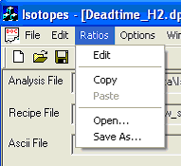Ratios>Edit allows to display in a dedicated box the ratios R0, R1, R2... corresponding to the spreadsheet columns, to modify these ratios, or to define new ratios. The ratio defining box is opened. For using this box, see § The ratio defining box.

Ratios>Copy allows to copy the ratios definition for the current spreadsheet.

Ratios>Paste allows to apply the ratios definition, which have been previously copied, to the currently loaded file. Each ratio is applied only if the species defining it have been measured for the current file.

Ratios>Paste allows to apply the ratios definition, which have been previously copied, to the currently loaded file. Each ratio is applied only if the species involved in the computation have been measured for the current file.

Ratios>Save as allows to save the current ratios definition on a file (.rto extension). A file manager dialog box is opened.

Ratios>Open allows to load a ratios definition file (.rto extension). Each ratio is applied to the currently loaded file with the condition that the species involved in the computation have been measured for the current file.
Contents ↑

The Options menu
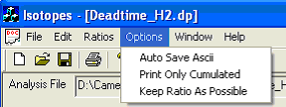
Options>Auto save Ascii Not available yet.

Options>Print only cumulated If this option is selected, only the cumulated results, and not the Block results, will be printed (File>Print function) or saved on a file (File>Save and File>Export to Excel functions).

Options>Keep ratio as possible This option allows to keep in memory the current ratios definition each time a new file is loaded. Each ratio is applied to the loaded file, with the condition that the species involved in the computation have been measured for this file.

Contents ↑

The ratio defining box

This box is purposed to define new ratios, to modify these ratios, or simply to display the already defined ratios.

The box allows to edit the different coefficients c1, c2, c3... associated to each measured species for building respectively the numerator and the denominator in the form
c1*M1 + c2*M2 + c3*M3 ... +c0
Obviously, zero will be often chosen. Note that the possibility to set all the denominator coefficients to zero except c0 (set to 1) allows to display the intensity of one measured species in the output spreadsheet.

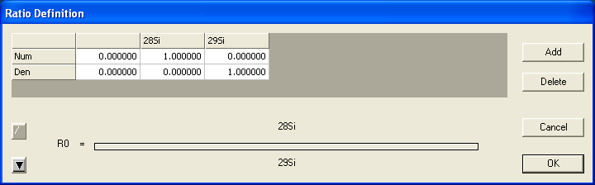

The scrolling buttons on the left bottom of the window are used to select between the ratios to be displayed.

Button Add allows to add a new ratio.
Button Delete deletes the currently displayed ratio.
Button Cancel closes the ratios definition box without any modification.
Button OK closes the ratios definition box and validates all modifications (ratios addition, edition, or suppression).
Contents ↑

The spreadsheet computed cells

This section contains a lot of formulas. The hereunder glossary may help the reader which requires to have a precise knowledge of the formulas involved in the Isotopes spreadsheet.

GLOSSARY

i (1 to N) | Cycle index in a N cycle analysis.
N | Total analysis number of cycles.
k (1 to B) | Block index in the same analysis.
B | Number of Blocks
j (1 to n=N/B) | Cycle index in a block
n | Number of cycles in a block
m (1 to M) | Mass index.
M | Total number of measured masses, defined in the species table.
Count_{m,i} (counts) | EM Raw data
I_{m,i} (A) | FC current
SR_{m,i} (cps) | Raw data signal
T_{m} (sec) | counting time related to the mass m.
Y_{m}, | Yield which is applied as a correction onto the raw data
bck_{m} (cps) | Background which is applied as a correction onto the raw data
dt_{m} (ns) | Deadtime which is applied as a correction onto the raw data
Sc_{m,i} (cps) | Data signal, after the (Yield, bkg, dt) corrections if required.
p_{m,i} | Slope dSR/dt
T_{cycle} (sec) | Overall cycle time
SC_{m,i} (cps) | Corrected data signal, including the linear drift correction, if required.
RAT_{i} | Ratio calculated over a single cycle
RAWRAT_{k} | Ratio calculated with the raw data SR.
NUMRAT_{k} | Numerator of RAWRAT_{k}
DENRAT_{k} | Denominator of RAWRAT_{k}
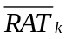 | Mean ratio calculated over a block
STDE_{k} | Ratio experimental standard deviation calculated over a block k
STER%_{k} (%) | experimental standard deviation of the mean computed over the block k (Estimated uncertainty of the ratio computed over the block k .)
POIS%_{k} (%) | Accuracy of the ratio computed over the block k data, if the single cause of uncertainty was the finite number of counts.
RATBLOCK_{k} | Ratio calculated with the overall data of the block k.
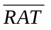 | Mean ratio calculated over the overall analysis cycles.
STDE | Ratio standard deviation calculated over the overall analysis set of blocks
STER% (%) | Estimated accuracy of the ratio computed over the overall analysis cycles.
POIS% (%) | Accuracy of the ratio computed over the overall analysis data, if the single cause of uncertainty was the finite number of counts.
RAT | Ratio calculated with the overall analysis data.

Let i (1 to N) be the cycle index in a N cycle analysis.
Let k (1 to B) be the block index in the same analysis.
Let j (1 to n=N/B) be the cycle index in a block.
Let m (1 to M) be the mass index.

Raw data SR_{m,i} (displayed in the Raw data panel and printed as Raw data)
All the raw data SR_{m,i} are expressed in counts per seconds.

- EM case
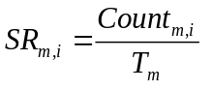
where T_{m} is the Mass m counting time, and Count_{m,i} the number of counted counts during T_{m}.

- Faraday case
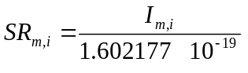
Where I_{m,i} is the Faraday current, measured in Ampere.

Corrected data SC_{m,i}
1st correction: Yield, background, deadtime.

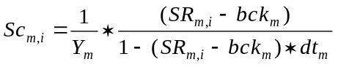

Where Y_{m}, bck_{m}, dt_{m} are respectively the yield, the background level and the deadtime corresponding to the Masse m.
For defining these corrections,see the previous section § The Main Spreadsheet panel.
For some comments about these corrections, see below the Appendix § The EM and Faraday corrections.
If a channel yield correction is not enabled, Y_{m} is set to 1. If a channel Background correction is not enabled, Bck_{m} is set to 1. If a channel deadtime correction is not enabled, dt_{m} is set to 0.

2nd correction Linear Drift
Defining the cycle slopes p_{m,i} as
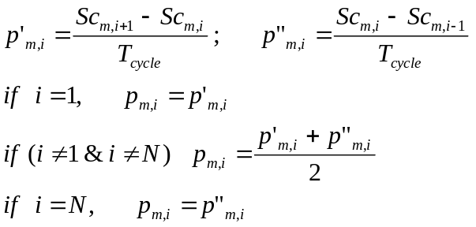

Where T_{cycle} is the overall cycle time, derived from the species table.
The linear drift correction is defined as
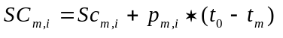

Where t_{m} is the cycle time location of the Mass m counting time and t₀ the reference cycle time location defined by the selection Linear drift (See above the section § The Main Spreadsheet panel).
For some comments about these corrections, see below the Appendix § The EM and Faraday corrections.

Ratios
Any numerator and denominator ratio can be defined as a linear combination of the species counting rate. (See the section § The ratio Defining box)
Cycle Ratio
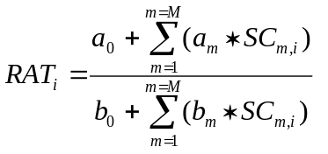

The cycle Raw Ratio is further used for the Poisson calculation
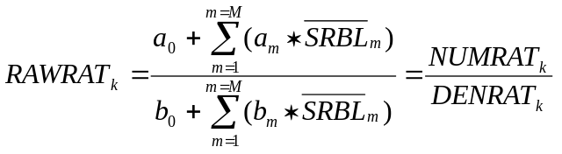

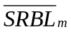is the mean SC_{m} computed over a block data.

Computation over one block data

The spreadsheet top half displays statistical computing within the block k. The displayed block k can be selected by the user (the incrementable box close to BLOCK RESULT #.
BLOCK RESULT # | k
 | R
Mean value | 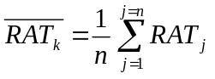
Std dev (STDE) | 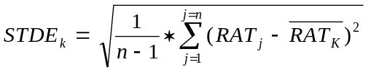
Std Err Mean (%) | 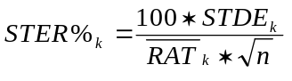
Poisson (%) | 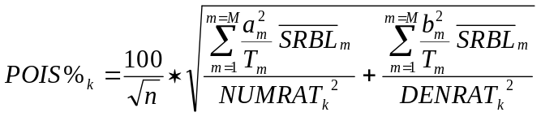
Integrated Mean | 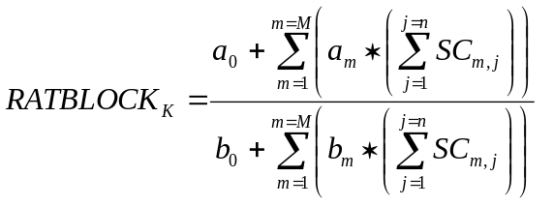

For some comments about how these formulas are derived from the basic statistical laws, see the appendix § Fundamental of Statistics.
When printing Statistics or Raw data, the above computed reults are listed for each block. In the case of Raw Data, the cycle data SR_{m,i} are also listed.

Computation over the cumutaled data

This spreadsheet bottom half displays the overall analysis result: One result for each ratio, with some additional data for estimating its uncertainty. A box located close to CUMULATED RESULTS allows to select OVER BLOCK/OVER DATA.

OVER BLOCK/OVER DATA In the case OVER BLOCKS, the block is considered as the elementary measurement, and then, the same statistical features as above, in the BLOCK spreadsheet are computed. In the case OVER DATA, the partitioning into block is not taken into account.

CUMULATED RESULTS | OVER DATA
 | R
exactly the same computation is achieved as in the case of one block (See above): A single block is considered, consisting of all the N analysis cycles.

The following table concerns only the case OVER BLOCKS
CUMULATED RESULTS |  | OVER BLOCKS
 | R
Mean value | 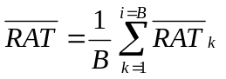
Std dev (STDE) | 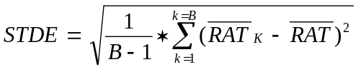
Std Err Mean (%) | 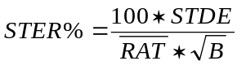
Poisson (%) | POIS% is the same than in the OVER DATA case, i.e., by considering a single block containing all the data .
Integrated Mean | 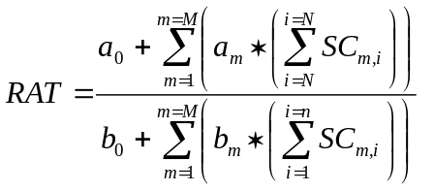

Contents ↑

Appendix: Fundamental of Statistics

Binomial law, poisson law, Normal law

A is an event which may occur along a test. If A does not occur, the opposite event B occurs. p is the probability that A occurs. So the probability of B is q=1-p

The binomial law

Let run n tests. Let be P_{n}(k) the probability that A occurs exactly k times (and thus B, n-k times)

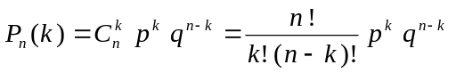

Let's assume now that n is a large number. It is possible therefore to calculate the mean and its spread σ.
= np
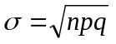
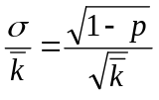

if p is very small
 | 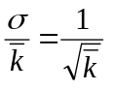 | (1)

The Poisson law and the Gauss law or Normal law

This very simple relationship can also be deduced from the Poisson law which gives P_{n}(k) when n is large

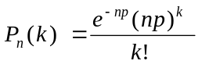

When n is very large, P_{n}(k) can be estimated by the Gauss law, also called Normal law.

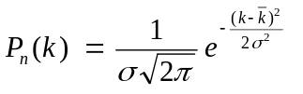

As a matter of fact, (1) can also be deduced from the Gauss law.

Properties of the normal law

Calculating the uncertainty of a measurement

So far it is established that the result R of a given counting test must follow the normal law

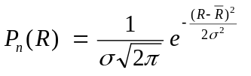

Let's define σ as the measurement uncertainty.

Let X₁, X₂, ... X_{i}, ... , X_{N} the actual results of N tests. The better estimation of σ which can be made with these 9 results is

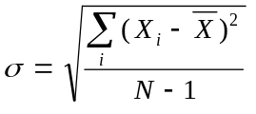
It is called the sample standard deviation or experimental standard deviation and currently written STDE.

Confidence interval
If a serie of n tests for determining gives an arithmetic mean of , so far the normal law is observed, there is a probability of 95% that the interval
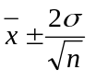
contains the actual mean x₀.

More generally, if a serie of n tests for determining gives an arithmetic mean of , there is a probability Θ(k) that the interval
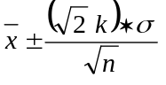
contains the actual mean x₀.

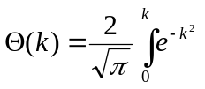

Θ(k) is called the error function.
Θ(k) | k | 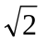k
0.9 | 1.163 | 1.644
0.99 | 1.821 | 2.575
0.999 | 2.327 | 3.291
0.9999 | 2.751 | 3.891

Estimating the accuracy of a measurement consisting of n sub-measurements

Let's define the accuracy as the standard deviation which would be observed if the measurement was repeated a large number of times.
If the sample standard deviation of the n sub-measurements is σ, the uncertainty of the measurement is
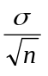
So far the statistical law ruling the n sub-measurements is actually a normal law.

Standard deviation of a Sum

Let's assume that Z=X+Y, X and Y being 2 random variables following a normal law caracterized respectivelty by their mean arithmetic value 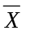 and 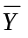 and their standard deviation σ_{X}, σ_{Y}.

Z distribution will also follow a normal law characterized by
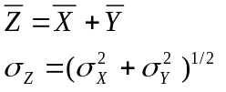

Standard deviation of a product

Let's assume that Z=X*Y, X and Y being 2 random variables following a normal law caracterized respectivelty by their mean arithmetic value and and their standard deviation σ_{X}, σ_{Y}.

Z distribution will also follow a normal law characterized by
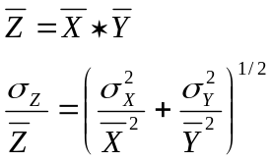

Standard deviation of a ratio

Let's assume that Z=X/Y, X and Y being 2 random variables following a normal law caracterized respectivelty by their mean arithmetic value and and their standard deviation σ_{X}, σ_{Y}.

Z distribution will also follow a normal law characterized by
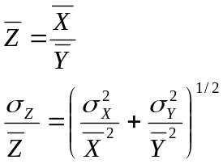

Consequence for the ion counting

When the mean number of counted ions is N during a given time τ, it can be said it is the result of repeating N*M tests for which the probability of counting one ion is 1/M. As M can be as large as desired, the formula (1) is relevant for calculating the standard deviation test result (N^{1/2}) which can be considered as the uncertainty of the test.
Consequently, when a ratio is defined as 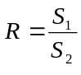, Where S₁ and S₂, expressed in counts per seconds (cps), are derived from two numbers of counts N₁ and N₂,

S₁ = N₁/T₁ S₂ = N₂/T₂

Where T₁ and T₂ are the respective counting times, accordingly to above formula giving the standard deviation of a ratio, there is an unavoidable uncertainty which can be expressed as
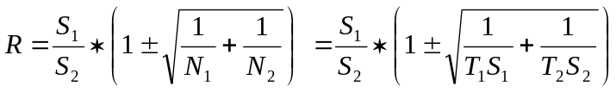

In the field of isotopic ratios, it can be relevant to define some more sophisticated ratios (for example, in the case of zircon analysis for achieving a common lead correction)

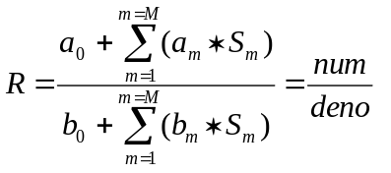

Where it is assumed that each signal S_{m} , expressed in cps, derives from a given number of counts:
S_{m} = N_{m}/T_{m}

It is possible to calculate the uncertainty of R by calculating firstly separately the absolute σ of both the numerator and the numerator (these σ are added in quadrature), and then, by adding in quadrature the relative standard deviations:

